**WEEK – 4**

**1#** Create a spreadsheet with mentioned entries.

Step-1: Open a Blank workbook.

Step-2: Start filling the entries.

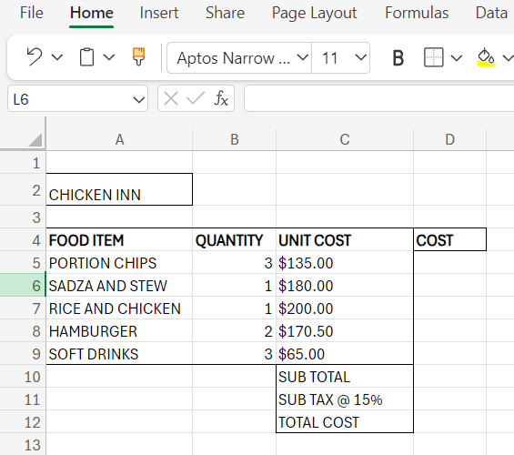

Step-3: Save the file as Qn2data.

Step-4: Now we will enter formula to calculate different values in each cell.

Similarly, we will calculate the amounts for subtotals, sales tax and total cost in D10 – D12 respectively.

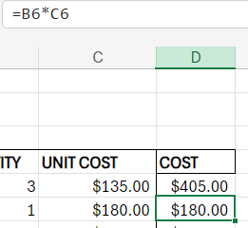 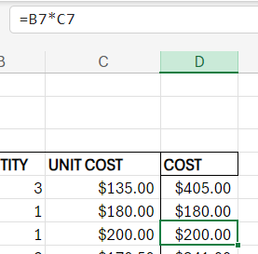 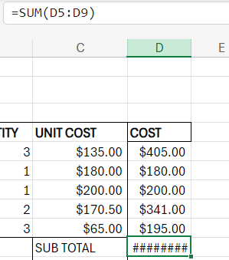 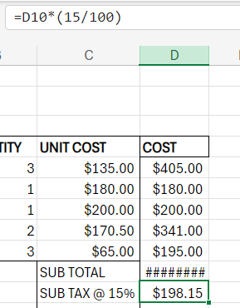

**CREATE A PIE GRAPH FOR FOOD ITEM AND QUANTITY**

**Step –1:** Select the data entries all the way from A4 to B9.

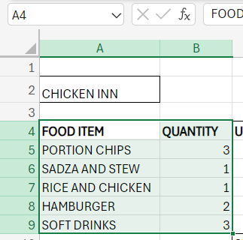

**Step-2:**  Go to Insert Tab. Select the Pie graph from the Graph section.



**Step-3:**  A Pie chart will be displayed. Edit the title and legends accordingly.

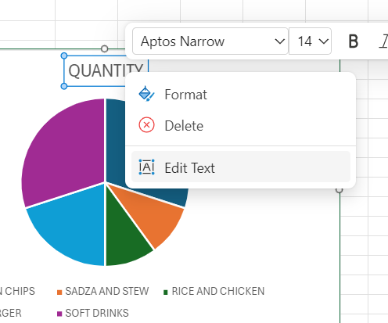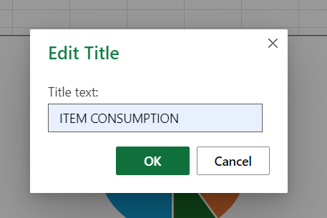

**Step-4:** Save this document as Qn2chicken.

**Step-5:** Now create another workbook, and write all the formulas you used to calculate the cell values.

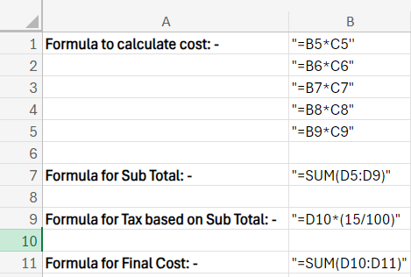

**Step-6:**  Lastly, Save the workbook as 'Formulas'.